

**CMSE 231**

**ESTABILISHED REAL ESTATE PORTAL PROJECT**

**FINAL REPORT**

**GROUP 5**

**DOĞUKAN GÜLER (TL): 17000252**

**ALEYNA YILMAZ: 21000166**

**FATİH ÇAKIR: 21000128**

**INSTRUCTOR: PROF. DR. HADİ IŞIK AYBAY**

**OUTLINE**

1. INTRODUCTION
2. PROJECT MANAGEMENT PLAN
3. OVERALL DESCRIPTION
4. FUNCTIONAL REQUIREMENTS
5. NON-FUNCTIONAL/QUALITY REQUIREMENTS
6. USER INTERFACE
7. CONCLUSION
8. REFERENCES
9. APPENDIX
10. **INTRODUCTION**

**Purpose**

Real estate search portal is a website designed to facilitate transactions such as real estate search, purchase, sale, rental and evaluation. This portal allows users to view, compare and query properties available in local or international markets. Additionally, the portal also provides users with additional services such as mortgage calculators, moving services, interior design solutions, legal advice and market trends.

**System Scope**

The system scope includes a description of the functions and features that the portal offers. System scope is determined by the portal's goals, audiences, requirements, constraints, and assumptions. The system scope also determines the success criteria and performance measures of the portal.

**Operating Environment**

The operating environment refers to the hardware, software, network and security components on which the portal runs. The operating environment provides the resources and infrastructure necessary to ensure that the portal operates in an efficient, secure and user-friendly manner. The operating environment may vary during the development, testing, deployment and maintenance phases of the portal.

**Design and Implementation Constraints**

Design and implementation constraints are factors that affect the development and operation of the portal. Design and implementation constraints ensure that the portal complies with technical, business, legal and ethical standards. Design and implementation constraints determine the portal's architecture, interface, data model, code quality, security protocols, compliance requirements, and testing strategies.

1. **PROJECT MANAGEMENT PLAN**

**Timeline:**

**Work Distribution:**

1. **OVERALL DESCRIPTION**

**SYSTEM ARCHITECTURE**

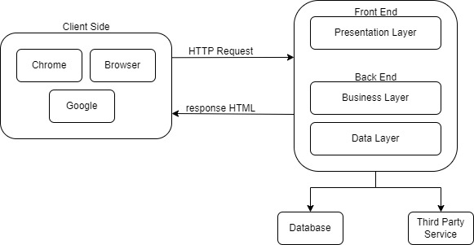

When a user types a query on Google using a Chrome browser, the browser sends an HTTP request to the front-end server. The front-end server is responsible for presenting the user interface and handling user interactions. The front-end server then passes the request to the back-end server, which is responsible for performing the business logic and accessing the data. The back-end server consists of three layers: presentation, business, and data. The presentation layer formats the data into HTML, which is the language that browsers understand. The business layer implements the core functionality of Google, such as ranking, filtering, and personalizing the search results. The business layer may also use third-party services, such as maps, ads, or videos, to enhance the user experience. The data layer retrieves the relevant data from the database, which is where the information is stored. The data layer then sends the data back to the presentation layer, which converts it into HTML. The HTML response is then sent back to the front-end server, which forwards it to the browser. The browser then displays the search results to the user. This is how a client-side request works in a nutshell.

**USE CASES**

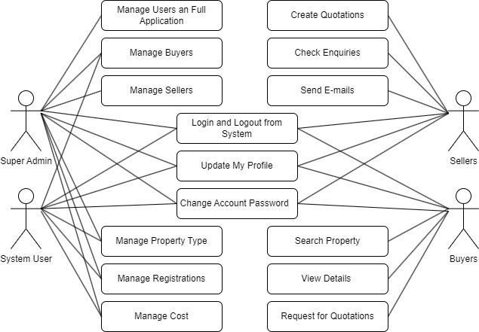

Use cases for a real estate search portal may include the following scenarios:

**Use case 1:** The user enters the portal's website, enters the desired location, property type, price range, number of rooms, square meters and other criteria in the search box, clicks the search button, the portal lists the properties suitable for the user, the user examines the list, compares the properties he likes, adds to the favourites adds, saves, shares or contacts advertisers.

**Use case 2:** The user downloads the portal's mobile application, opens the application, activates the location service, views properties near him, marks properties on the map, reads property details, watches property photos or videos, sees property reviews or ratings, sends a message to the advertiser if he likes the property, or calls.

**Use case 3:** The user enters the portal's website, selects moving services from the menu, enters the location to be moved, the date to be moved, the type of property to be moved to, the size of the property to be moved to and other information on the moving services page, the portal lists the moving companies suitable for the user, the user examines the list, the moving location he likes is He compares the companies, gets a quote, sees their comments or scores, and makes an agreement with the moving company.

**Use case 4:** The user enters the portal's website, selects the interior design solutions from the menu, enters the desired property type, property size, design style, budget and other information on the interior design solutions page, the portal lists the interior designers suitable for the user, the user examines the list, selects the interior he likes compares designers, sees their portfolios, comments or ratings, and contacts the interior designer.

**Use case 5**: The user enters the portal's website, selects legal consultancy services from the menu, enters the desired property type, property size, purchase-sale agreement, title deed transactions and other information on the legal consultancy services page, the portal lists the legal advisors suitable for the user, the user examines the list, compares the legal advisors he/she likes, sees their comments or scores, and contacts the legal advisor.

**Use case 6:** The user enters the portal's website, selects market trends from the menu, enters the desired location, property type, time period and other information on the market trends page, the portal shows the user relevant market trends, the user examines market trends, property prices, supply-demand It sees the balance, return on investment, competitive situation and other factors, and makes decisions based on market trends.

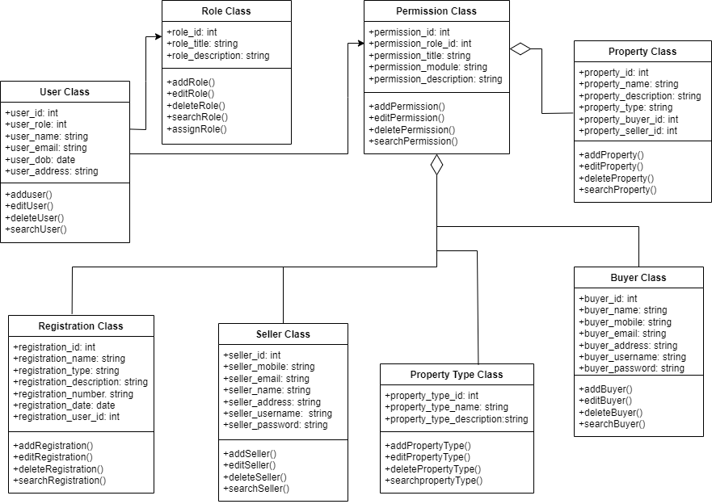**CLASS DIAGRAM**

1. **FUNCTIONAL REQUIREMENTS**
   1. **User Requirements**

REQ-1: Users can register and log in.

REQ-2: Users can manage their account (adding profile photo, editing personal information, etc.).

REQ-3: Users can reset or update their passwords.

REQ-4: Users can use two-factor authentication (Mobile phone, email verification).

REQ-5: Users can have the authority to review other users’ profiles.

REQ-6: Users can delete their accounts and their data if they want.

* + 1. **Buyer Requirements**

REQ-1: Buyer can search for properties and narrow down results with various filtering options.

REQ-2: Buyer can add properties they like to favorite and access them easily later.

REQ-3: The buyer can pay using secure payment methods.

* + 1. **Seller Requirements**

REQ-1: The seller can create a property listing and enter relevant information (location, price, number of rooms, etc.).

REQ-2: The seller can edit or delete existing listings.

REQ-3: The seller can review the statistics for listings (number of views, added to favorites, etc.).

REQ-4: The seller can start the sale transaction and receive payment.

REQ-5: The sellers can display their properties on the location.

* + 1. **Admin Requirements**

REQ-1: The admin can create, edit, or close new or current user accounts.

REQ-2: The admin can filter or delete inappropriate content.

REQ-3: The admin can display and analyze general system statistics.

REQ-4: The admin can reach database and display user data.

REQ-5: The admin can check system backup operations.

1. **NONFUNCTIONAL/QUALITY REQUIREMENTS**
   1. **System Requirements**

* The website should load quickly.
* The website should be open and accessible 24/7.
  1. **Security Requirements**
* The website should have an SSL certificate and protect the data of users.
* The website should have a firewall which provides protection from DDoS attacks.
  1. **Usability Requirements**
* The website should have a user-friendly interface.
* The website should work properly on the mobile platform, as well.
* The website should have a live support assistant which 24/7 open.
  1. **Compatibility Requirements**
* The website should be compatible with different internet browsers and devices.
  1. **Maintenance:**
* The system should update and maintain the website regularly.
* The system should backup system data and being recoverable regularly.

1. **USER INTERFACE**

1. **CONCLUSION**

This report is a summary of the issues we pay attention to in making a real estate agent web application. In this report, we presented the design and development process of a real estate agent web application, as well as the content, target audience, competitive situation, legal obligations, and revenue model of the web site. We also explained the features and functions of the web site, such as language options, advanced search filters, sorting options, map view, comparison feature, adding to favorites, contact form, comment and rating, social media sharing and content creation. This report is based on the knowledge and skills in topics such as web design, database management, search engine optimization and security protocols. The purpose of this report is to provide a comprehensive and informative guide for making a user-friendly, fast, secure, and easily accessible real estate agent web application. As a web developer, we need to understand the needs and expectations of our clients, as well as the market conditions and trends. We need to communicate effectively with our clients, listen to their feedback, and deliver the best possible solution for their problems.

1. **REFERENCES**

* [How to Build a Real Estate App I Real Estate App Development Guide (ascendixtech.com)](https://ascendixtech.com/real-estate-web-application-development/)
* [Real Estate Web Application - Echopx Technologies | Website design & Development | SEO Company](https://echopx.com/real-estate-web-application-2/)
* [Software Requirements Analysis with Example (guru99.com)](https://www.guru99.com/learn-software-requirements-analysis-with-case-study.html)
* Sharma Tushar (2012-2013) / **A Project Report On “REAL ESTATE LISTING WEB APPLICATION”** / Roll No. 91133313 / Enrollment No. SGVU091133313
* RASHI CHOPRA / **REAL ESTATE WEB APPLICATION** / B.E., Medicaps Institute of Technology and Management, India, 2006 / KANSAS STATE UNIVERSITY / Manhattan, Kansas 2008
* [19 Problems of Being in a Real Estate Industry [With Solutions] (salesmate.io)](https://www.salesmate.io/blog/problems-of-being-in-real-estate-industry/)
* [Data Collection | Definition, Methods & Examples (scribbr.com)](https://www.scribbr.com/methodology/data-collection/)
* [Real Estate Web Development | inMotion Real Estate Media](https://inmotionrealestate.com/solutions/web-development/)
* [Zillow: Real Estate, Apartments, Mortgages & Home Values](https://www.zillow.com/)
* [realtor.com® | Homes for Sale, Apartments & Houses for Rent](https://www.realtor.com/)
* [Trulia: Real Estate Listings, Homes for Sale, Housing Data](https://www.trulia.com/)
* [Apartments and Houses for Rent | realtor.com®](https://www.realtor.com/rentals/)

**9. APPENDIX**

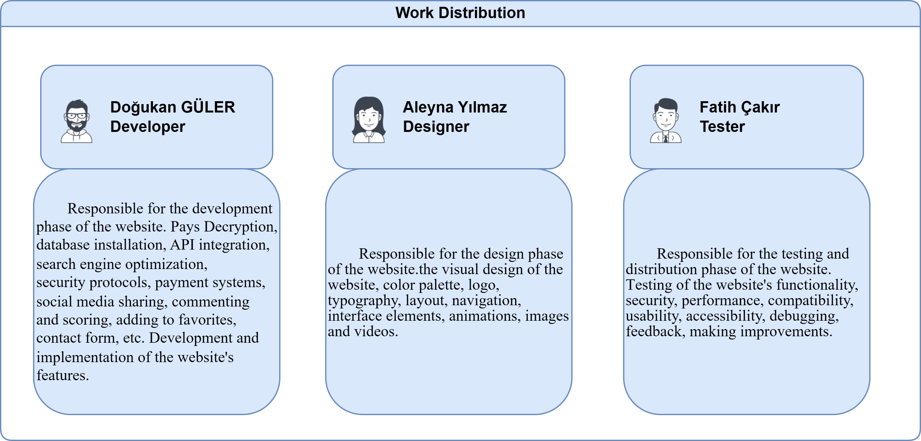

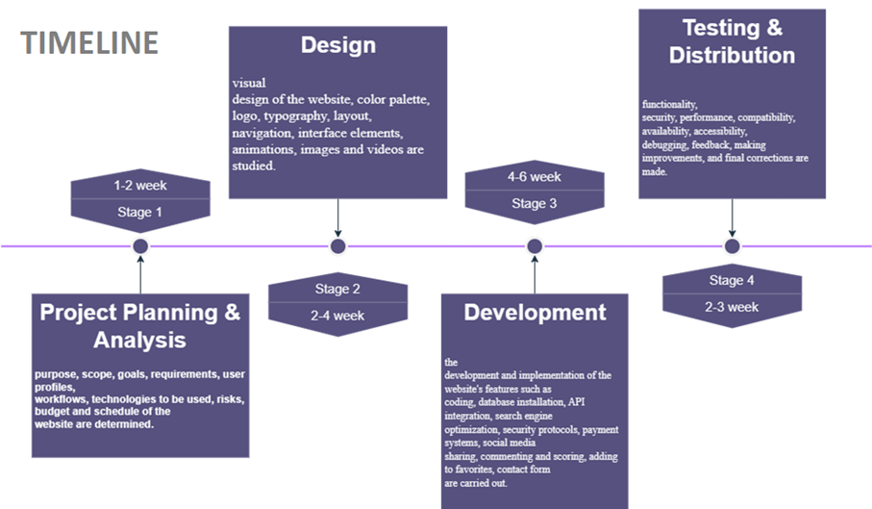

**SYSTEM ARCHITECTURE DIAGRAM**



**USE CASE DIAGRAM**



**CLASS DIAGRAM**



**MODULAR HIERARCHY DIAGRAM**

